M.V.P. Samaj, Nashik
GMD Arts, BW Commerce & Science College, Sinnar, Nashik-422 103.
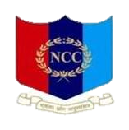
NATIONAL CADET CORPS
(ARMY WING)
COY- C PLATOON NO. 7 & 8
7 MAH BN NCC, NASHIK
GP: MUMBAI ‘B’
DTE- MAHARASHTRA
NCC ALUMNI ASSOCIATION LIFE MEMBERSHIP CARDS

